Tool Shed Website Documentation

This is assuming you have python 3, pip and Django installed. If you don’t click the links to install:

Python 3: <https://www.python.org/downloads/release/python-376/>

Pip: <https://pip.pypa.io/en/stable/>  
Django: After you have pip installed type:

pip install django

# The Website

## Starting the Website

Open the terminal and move to the src directory and input the following line:

python manage.py runserver

Go to the web address that the terminal returns. You should be able to find it on this line:

Starting development server at <webaddress>

If this is the first time using the website, you need to initialize the database by going to the web address

<webaddress>/setup

## Creating A User

In order to create orders, you must create a user profile by clicking register in the upper right-hand menu. After signing up and logging in, you should be directed to your profile page. You need to update your profile information before continuing.

## Creating an Order

After updating your user profile, you can create a reservation by clicking on view products on the profile screen or on the menu. If there are no products type:

<webaddress>/setup

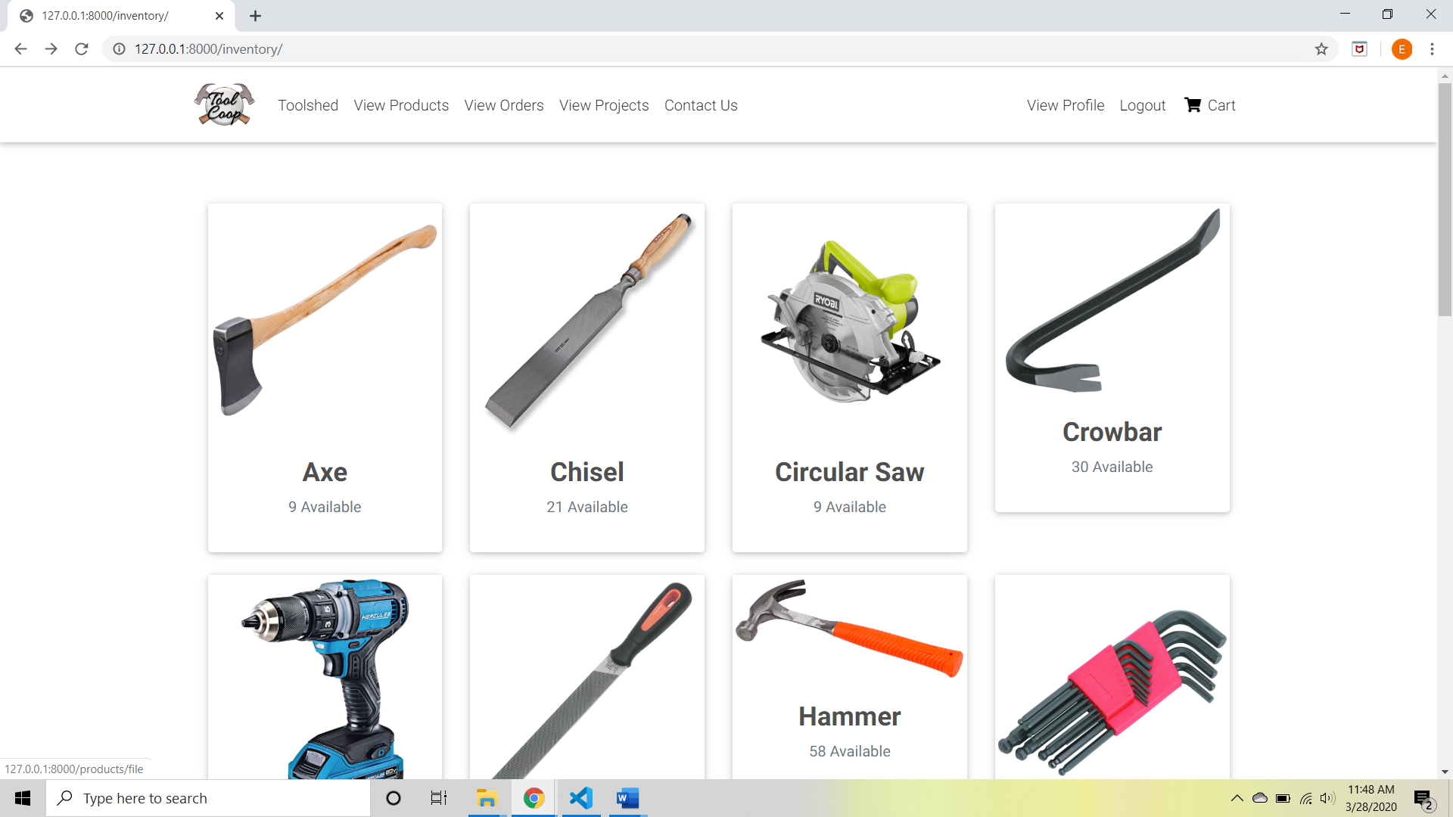

Choose your tool and add an item to the cart. When you add the item to the cart, you will be redirected to the order summary where you can update your quantities.

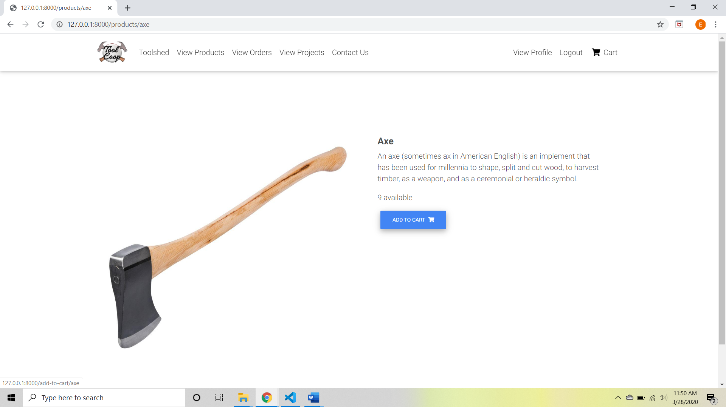

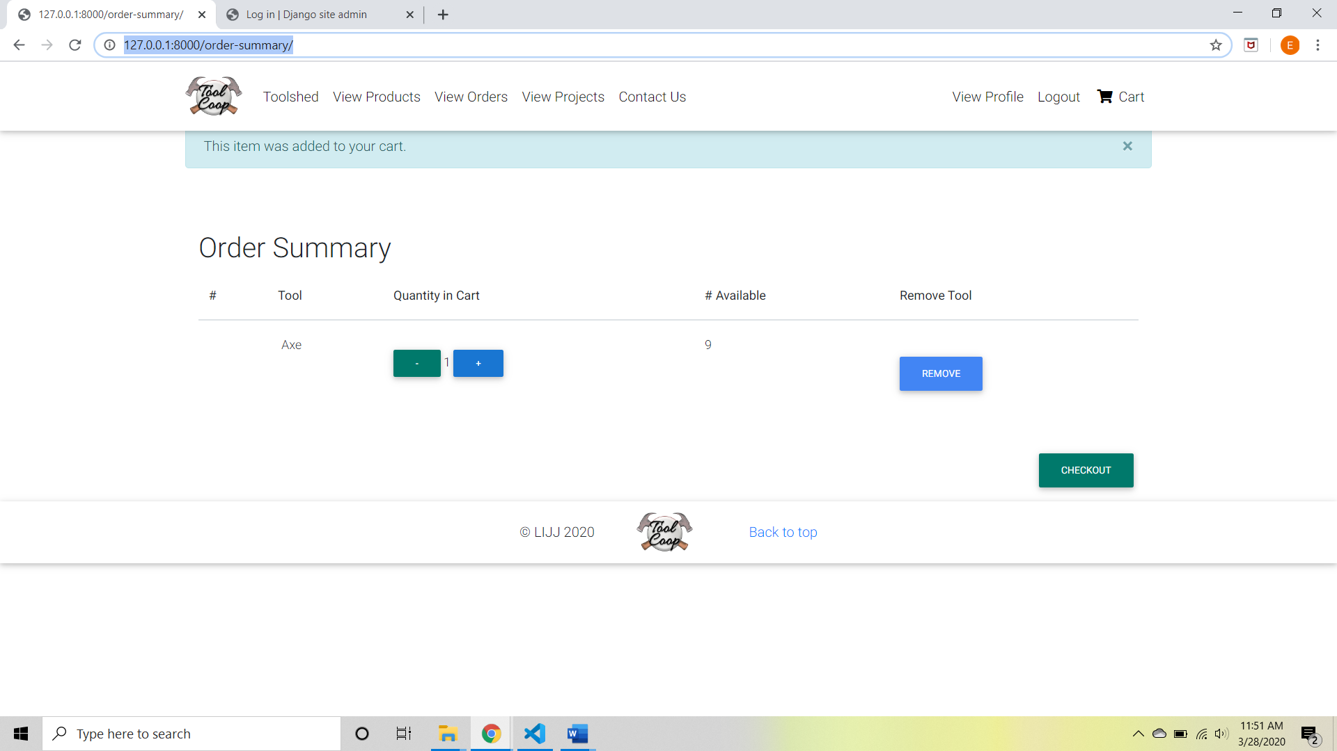

When you have your cart completed, you can go to checkout. Verify that your information is correct, input the reservation start and end dates, and submit.

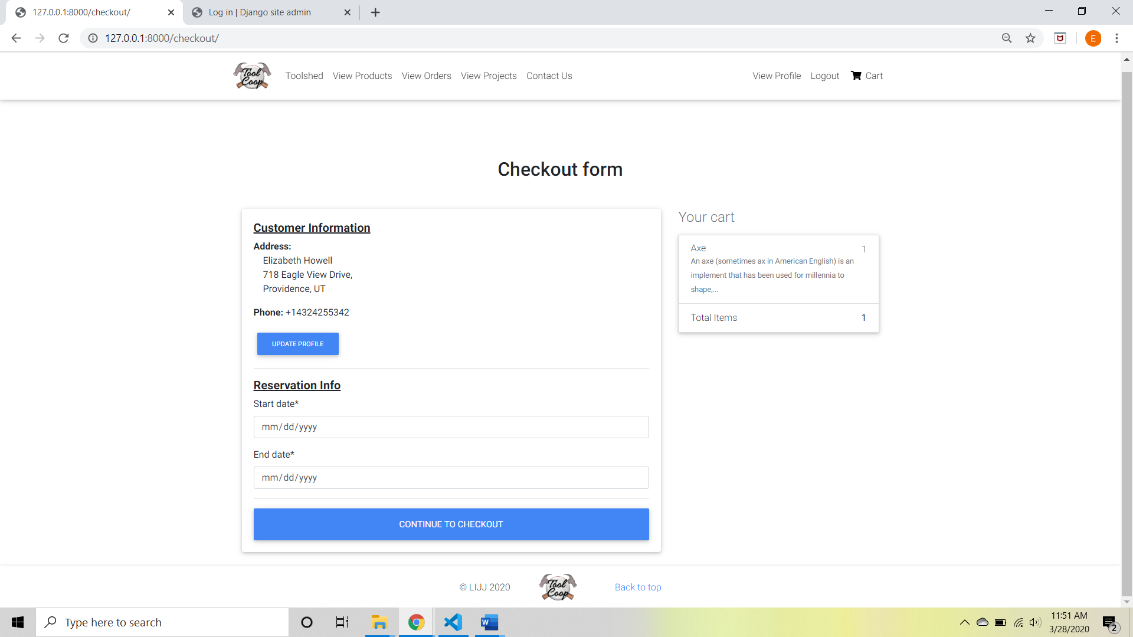

If your submission is complete, you should redirect to the front page and get a message that your order has been sent.

## Other Pages

The admin–order-page:

Now we have included the orders page with the general customer pages for the time being. The admin can select and view reservations. The ability to check out is not available yet.

The front, product, and contact us pages are all static at the moment. The ability to send an email through the contact page is in the works.

## Works in Progress

Next, we will work on admin checkout and the admin’s ability to make orders for other people and setting permissions.

# The Test Environment

Open the terminal to test the order logic from creating a reservation to checkout. To begin the tests type :

python manage.py test

You should be able to see all phases of the test in your terminal.